**NAME : EZRA KIPYEGON**

**REGISTRATION Number : C026-01-0739/2020**

**UNIT : SYSTEM PROGRAMMING**

**TASK : ASSIGNMENT**

1.WRITING TO A FILE

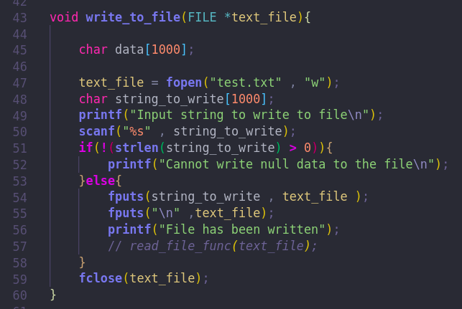

RESULT:

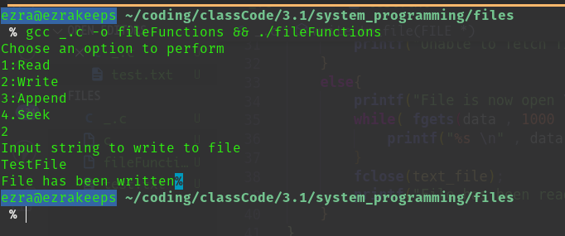

2.READING FROM A FILE

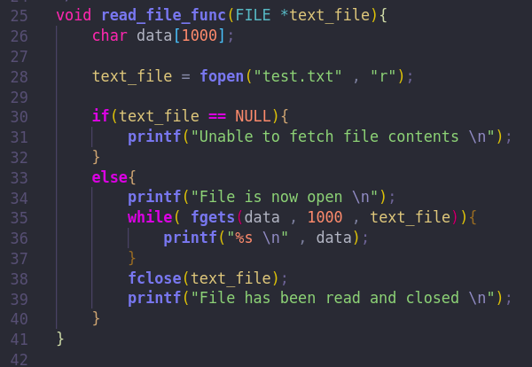

RESULT:

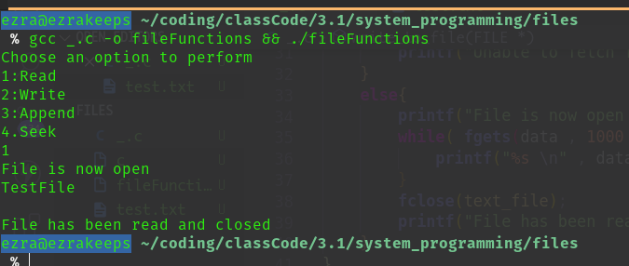

3.APPEND TO A FILE

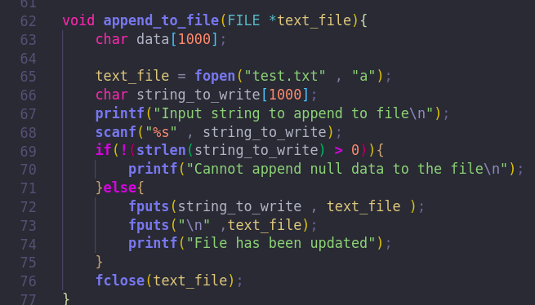

RESULT:

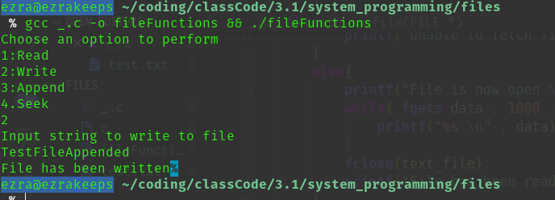

4.SEEK

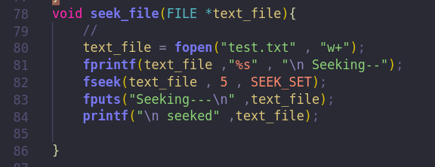

RESULT

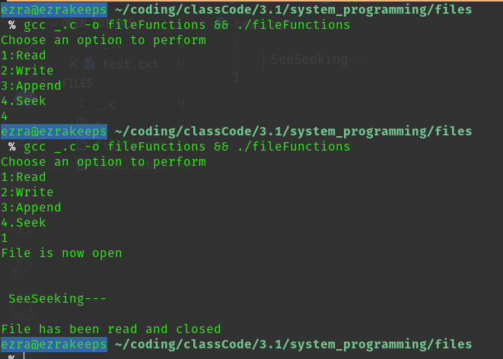

5.MAIN FUNCTION

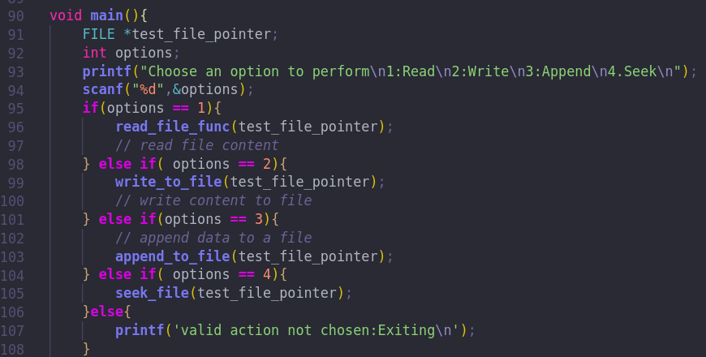THE CODE WAS COMPILED USING THE INBUILT GCC C COMPILER IN LINUX

**CODE FOR CODE COMPILATION AND RUNNING**

Code Base File Name : _.c

gcc _.c -o fileFunctions && ./fileFunctions